7. WAP to implement a circular queue in c

#include <stdio.h>
#include <stdlib.h>

#define MAX_SIZE 5

typedef struct {
int* elements;
int front;
int rear;
int size;
} CircularQueue;

CircularQueue* createQueue() {
CircularQueue* queue = (CircularQueue*)malloc(sizeof(CircularQueue));
queue->elements = (int*)malloc(MAX_SIZE * sizeof(int));
queue->front = -1;
queue->rear = -1;
queue->size = 0;
return queue;
}

int isFull(CircularQueue* queue) {
return (queue->front == 0 && queue->rear == MAX_SIZE - 1) || (queue->front == queue->rear + 1);
}

int isEmpty(CircularQueue* queue) {
return queue->front == -1;
}

void enqueue(CircularQueue* queue, int data) {
if (isFull(queue)) {
printf("Queue is full. Cannot enqueue element.\n");
return;
}

if (queue->front == -1)
queue->front = 0;

queue->rear = (queue->rear + 1) % MAX_SIZE;
queue->elements[queue->rear] = data;
queue->size++;

printf("Enqueued element: %d\n", data);
}

int dequeue(CircularQueue* queue) {
if (isEmpty(queue)) {
printf("Queue is empty. Cannot dequeue element.\n");
return -1;
}

int data = queue->elements[queue->front];
if (queue->front == queue->rear)
queue->front = queue->rear = -1;
else
queue->front = (queue->front + 1) % MAX_SIZE;

queue->size--;

return data;
}

int main() {
CircularQueue* queue = createQueue();

enqueue(queue, 10);
enqueue(queue, 20);
enqueue(queue, 30);
enqueue(queue, 40);
enqueue(queue, 50);
enqueue(queue, 60);

printf("Dequeued element: %d\n", dequeue(queue));
printf("Dequeued element: %d\n", dequeue(queue));
printf("Dequeued element: %d\n", dequeue(queue));
printf("Dequeued element: %d\n", dequeue(queue));
printf("Dequeued element: %d\n", dequeue(queue));
printf("Dequeued element: %d\n", dequeue(queue));

free(queue->elements);
free(queue);

return 0;
}
OUTPUT:
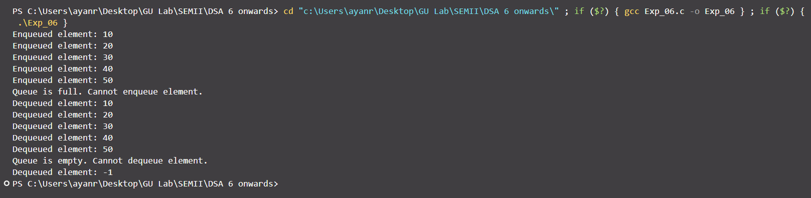

8. Write to get the nth node in linked list
#include <stdio.h>
#include <stdlib.h>

typedef struct Node
{
int data;
struct Node *next;
} Node;

Node *createNode(int data)
{
Node *newNode = (Node *)malloc(sizeof(Node));
newNode->data = data;
newNode->next = NULL;
return newNode;
}

Node *insertNode(Node *head, int data)
{
Node *newNode = createNode(data);
if (head == NULL)
{
head = newNode;
}
else
{
Node *temp = head;
while (temp->next != NULL)
{
temp = temp->next;
}
temp->next = newNode;
}
return head;
}

int getNodeValue(Node *head, int position)
{
if (head == NULL)
{
printf("Error: Linked list is empty.\n");
return -1;
}

Node *temp = head;
int count = 1;
while (temp != NULL && count != position)
{
temp = temp->next;
count++;
}

if (temp == NULL)
{
printf("Error: Position out of range.\n");
return -1;
}

return temp->data;
}

void freeLinkedList(Node *head)
{
Node *temp;
while (head != NULL)
{
temp = head;
head = head->next;
free(temp);
}
}

int main()
{
Node *head = NULL;
int n, data;

printf("Enter the number of elements: ");
scanf("%d", &n);

printf("Enter the elements:\n");
for (int i = 0; i < n; i++)
{
scanf("%d", &data);
head = insertNode(head, data);
}

int position;
printf("Enter the position of the node to retrieve: ");
scanf("%d", &position);

int nodeValue = getNodeValue(head, position);
if (nodeValue != -1)
{
printf("Value of the node at position %d: %d\n", position, nodeValue);
}

freeLinkedList(head);
return 0;
}

OUTPUT:
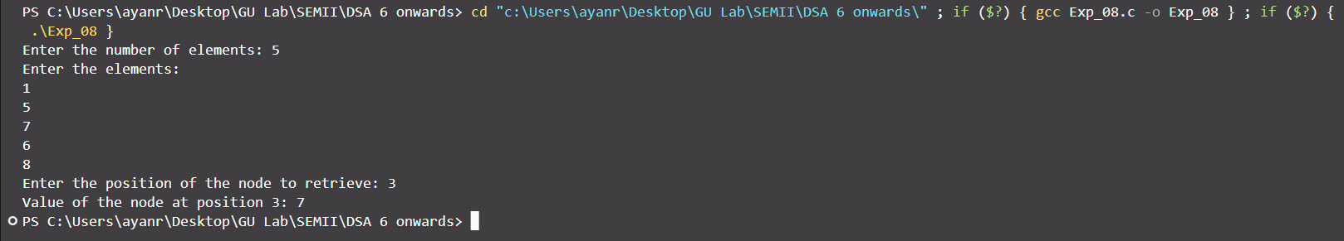
9. WAP program to implement binary search tree
#include <stdio.h>
#include <stdlib.h>

typedef struct TreeNode
{
int data;
struct TreeNode *left;
struct TreeNode *right;
} TreeNode;

TreeNode *createNode(int data)
{
TreeNode *newNode = (TreeNode *)malloc(sizeof(TreeNode));
newNode->data = data;
newNode->left = NULL;
newNode->right = NULL;
return newNode;
}

TreeNode *insert(TreeNode *root, int data)
{
if (root == NULL)
{
root = createNode(data);
}
else if (data <= root->data)
{
root->left = insert(root->left, data);
}
else
{
root->right = insert(root->right, data);
}
return root;
}

int search(TreeNode *root, int key)
{
if (root == NULL)
{
return 0;
}
else if (key == root->data)
{
return 1;
}
else if (key < root->data)
{
return search(root->left, key);
}
else
{
return search(root->right, key);
}
}

void inorderTraversal(TreeNode *root)
{
if (root != NULL)
{
inorderTraversal(root->left);
printf("%d ", root->data);
inorderTraversal(root->right);
}
}

void freeTree(TreeNode *root)
{
if (root != NULL)
{
freeTree(root->left);
freeTree(root->right);
free(root);
}
}

int main()
{
TreeNode *root = NULL;

root = insert(root, 50);
root = insert(root, 30);
root = insert(root, 20);
root = insert(root, 40);
root = insert(root, 70);
root = insert(root, 60);
root = insert(root, 80);

printf("Inorder traversal: ");
inorderTraversal(root);
printf("\n");

int key;
printf("Enter a key to search: ");
scanf("%d", &key);

if (search(root, key))
{
printf("Key %d found in the BST.\n", key);
}
else
{
printf("Key %d not found in the BST.\n", key);
}

freeTree(root);

return 0;
}

OUTPUT:
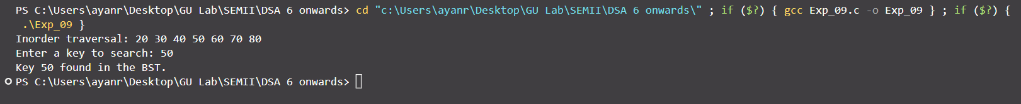

10. WAP program to implement insertion sort.
#include <stdio.h>

void insertionSort(int arr[], int n) {
int i, j, key;
for (i = 1; i < n; i++) {
key = arr[i];
j = i - 1;

// Move elements of arr[0..i-1], that are greater than key, to one position ahead of their current position
while (j >= 0 && arr[j] > key) {
arr[j + 1] = arr[j];
j = j - 1;
}
arr[j + 1] = key;
}
}

void printArray(int arr[], int n) {
int i;
for (i = 0; i < n; i++) {
printf("%d ", arr[i]);
}
printf("\n");
}

int main() {
int arr[] = {12, 11, 13, 5, 6};
int n = sizeof(arr) / sizeof(arr[0]);

printf("Array before sorting: ");
printArray(arr, n);

insertionSort(arr, n);

printf("Array after sorting: ");
printArray(arr, n);

return 0;
}
OUTPUT:

11. WAP program to implement bubble sort.

#include <stdio.h>
void bubbleSort(int arr[], int n)
{
int i, j, temp;
for (i = 0; i < n - 1; i++)
{
// Last i elements are already in place
for (j = 0; j < n - i - 1; j++)
{
// Swap adjacent elements if they are in the wrong order
if (arr[j] > arr[j + 1])
{
temp = arr[j];
arr[j] = arr[j + 1];
arr[j + 1] = temp;
}
}
}
}

void printArray(int arr[], int n)
{
int i;
for (i = 0; i < n; i++)
{
printf("%d ", arr[i]);
}
printf("\n");
}

int main()
{
int arr[] = {64, 34, 25, 12, 22, 11, 90};
int n = sizeof(arr) / sizeof(arr[0]);

printf("Array before sorting: ");
printArray(arr, n);

bubbleSort(arr, n);

printf("Array after sorting: ");
printArray(arr, n);

return 0;
}
OUTPUT:

12. WAP program to implement Quick Sort.
#include <stdio.h>

void swap(int *a, int *b)
{
int temp = *a;
*a = *b;
*b = temp;
}

int partition(int arr[], int low, int high)
{
int pivot = arr[high];
int i = (low - 1);

for (int j = low; j <= high - 1; j++)
{
if (arr[j] < pivot)
{
i++;
swap(&arr[i], &arr[j]);
}
}
swap(&arr[i + 1], &arr[high]);
return (i + 1);
}

void quickSort(int arr[], int low, int high)
{
if (low < high)
{
int pi = partition(arr, low, high);
quickSort(arr, low, pi - 1);
quickSort(arr, pi + 1, high);
}
}

void printArray(int arr[], int size)
{
int i;
for (i = 0; i < size; i++)
{
printf("%d ", arr[i]);
}
printf("\n");
}

int main()
{
int arr[] = {10, 7, 8, 9, 1, 5};
int n = sizeof(arr) / sizeof(arr[0]);

printf("Array before sorting: ");
printArray(arr, n);

quickSort(arr, 0, n - 1);

printf("Array after sorting: ");
printArray(arr, n);

return 0;
}

OUTPUT:

13. WAP program to implement Merge sort.
#include <stdio.h>

void merge(int arr[], int left, int middle, int right)
{
int i, j, k;
int n1 = middle - left + 1;
int n2 = right - middle;

// Create temporary arrays
int L[n1], R[n2];

// Copy data to temporary arrays L[] and R[]
for (i = 0; i < n1; i++)
L[i] = arr[left + i];
for (j = 0; j < n2; j++)
R[j] = arr[middle + 1 + j];

// Merge the temporary arrays back into arr[left..right]
i = 0; // Initial index of first subarray
j = 0; // Initial index of second subarray
k = left; // Initial index of merged subarray
while (i < n1 && j < n2)
{
if (L[i] <= R[j])
{
arr[k] = L[i];
i++;
}
else
{
arr[k] = R[j];
j++;
}
k++;
}

// Copy the remaining elements of L[], if there are any
while (i < n1)
{
arr[k] = L[i];
i++;
k++;
}

// Copy the remaining elements of R[], if there are any
while (j < n2)
{
arr[k] = R[j];
j++;
k++;
}
}

void mergeSort(int arr[], int left, int right)
{
if (left < right)
{
int middle = left + (right - left) / 2;

// Sort first and second halves
mergeSort(arr, left, middle);
mergeSort(arr, middle + 1, right);

merge(arr, left, middle, right);
}
}

void printArray(int arr[], int size)
{
int i;
for (i = 0; i < size; i++)
{
printf("%d ", arr[i]);
}
printf("\n");
}

int main()
{
int arr[] = {12, 11, 13, 5, 6, 7};
int n = sizeof(arr) / sizeof(arr[0]);

printf("Array before sorting: ");
printArray(arr, n);

mergeSort(arr, 0, n - 1);

printf("Array after sorting: ");
printArray(arr, n);

return 0;
}

OUTPUT:

14. Directed Graph Implementation.
#include <stdio.h>
#include <stdlib.h>

#define MAX_VERTICES 100

typedef struct Node
{
int vertex;
struct Node *next;
} Node;

typedef struct Graph
{
Node *adjacencyList[MAX_VERTICES];
int numVertices;
} Graph;

Node *createNode(int v)
{
Node *newNode = (Node *)malloc(sizeof(Node));
newNode->vertex = v;
newNode->next = NULL;
return newNode;
}

Graph *createGraph(int numVertices)
{
Graph *graph = (Graph *)malloc(sizeof(Graph));
graph->numVertices = numVertices;

for (int i = 0; i < numVertices; i++)
{
graph->adjacencyList[i] = NULL;
}

return graph;
}

void addEdge(Graph *graph, int src, int dest)
{
Node *newNode = createNode(dest);
newNode->next = graph->adjacencyList[src];
graph->adjacencyList[src] = newNode;
}

void printGraph(Graph *graph)
{
for (int i = 0; i < graph->numVertices; i++)
{
Node *temp = graph->adjacencyList[i];
printf("Adjacency list of vertex %d: ", i);
while (temp)
{
printf("%d -> ", temp->vertex);
temp = temp->next;
}
printf("NULL\n");
}
}

int main()
{
int numVertices = 4;
Graph *graph = createGraph(numVertices);

addEdge(graph, 0, 1);
addEdge(graph, 0, 2);
addEdge(graph, 1, 2);
addEdge(graph, 2, 0);
addEdge(graph, 2, 3);
addEdge(graph, 3, 3);

printGraph(graph);

return 0;
}

OUTPUT:
